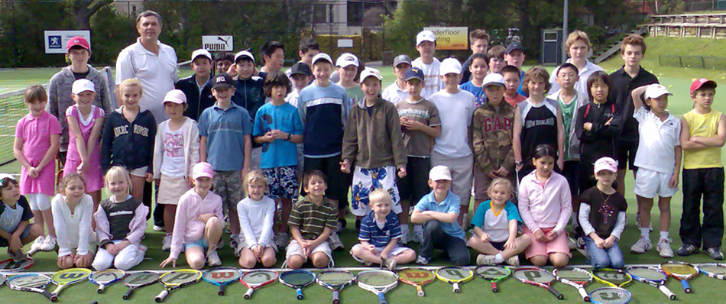
SCHOOL HOLIDAY TENNIS CLINIC
AT PARNELL LAWN TENNIS CLUB (Auckland Domain – next to Museum)
FOR MORE DETAILED PROGRAM INFORMATION PLEASE VISIT http://www.parnelllawntennisclub.co.nz/junior-programme/
Come and join us for some great tennis and fun at Parnell TC, NZ’s premier club.
We endeavor to structure groups according to player ability from beginner to advanced standards. FLEXIBLE ENROLMENTS CHOOSE WHICHEVER DAYS SUIT YOUR CHILD THE BEST.

FIRST WEEK: 21, 22, 23, 24 December 2020
SECOND WEEK: 28, 29, 30, 31 December

WEEK ONE: 4, 5, 6, 7, 8 January 2021
WEEK TWO: 18, 19, 20, 21, 22 January
WEEK THREE: 25, 26, 27, 28, 29 January

AGE: 5-18 years old

TIME & COST:
9:00 am to 12 noon (Morning Clinic) $180 or $45 per day
12:00 noon to 3:00 pm (Afternoon Clinic) $180 or $45 per day
9:00 am to 3:00 pm (FULL DAY CLINIC) $340 or $80 per day
------------------------------------------------------------------------------------------------

A NEW 8 WEEK COURSE AT PARNELL LAWN TENNIS CLUB

DATES: Saturdays: February (2021) 13, 20, 27. March 6, 13, 20, 27. April 3.
Sundays: February 14, 21, 28. March 7, 14, 21, 28. April 4.
TIME: 8:00 – 9:00 am for 5-18 years old
Tuesdays: Feb 9, 16, 23. Mar 2, 9, 16, 23, 30 (Time: 7-8am, Age: 10-18)
COST: $180 for 8 weeks or $25 for one week

TENNIS FOR ADULTS!!! (Beginners only) is on Saturdays from 8am to 9am.
ENQUIRIES: Coach, Goran Marsic NZPTCA (Level 2), TCNZ (Competition Coach), 29 years experience.
Phone: (021) 167-7460, (09) 377-9393, E-mail: gmarsic@gmail.com

